**Math.PI**

This is a mathematical object used to print pi constant number.

Remember that PI (**π**) is a constant rad number equal to 3.14.

**Syntax**: Math.PI

**Example 1:**



You can convert rad number to degree number and the verse.

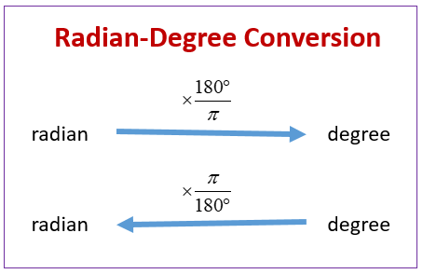

**Example 2:**

